MHS Enrichment Coding Continuum – ACTIVITY # 10

If you have successfully continued all of the Activities on the Coding Continuum from Activities 1-9 and all have been initialed, you can try experimenting with one of the MBots or Sphero or LBR. Each will require special software, see Mr.Desjardins for support/challenges.
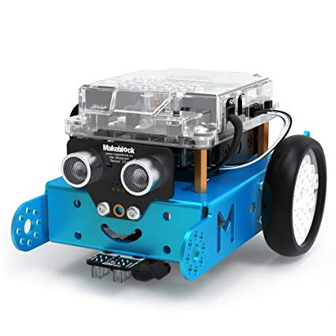
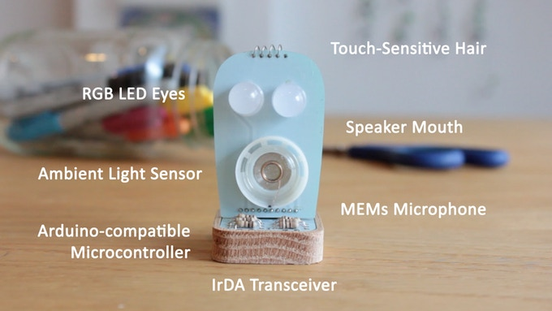
http://www.mblock.cc/mblock-software/
https://learn.littlerobotfriends.com/downloads/

